**Game Design Document**

**High Concept:**

The Concept of this game is a basic platformer, Like Super Mario. Except in this case, it’s a young girl travelling throughout the lands fighting monsters and trying to survive.

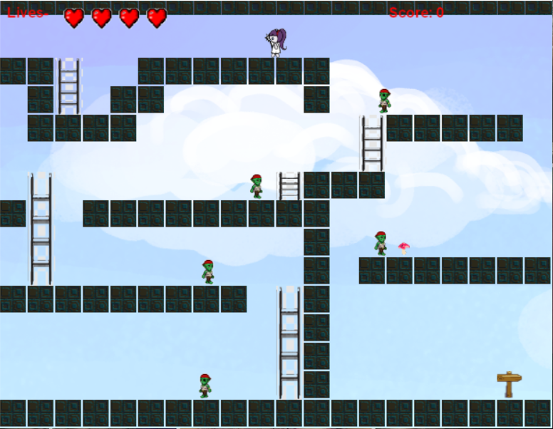 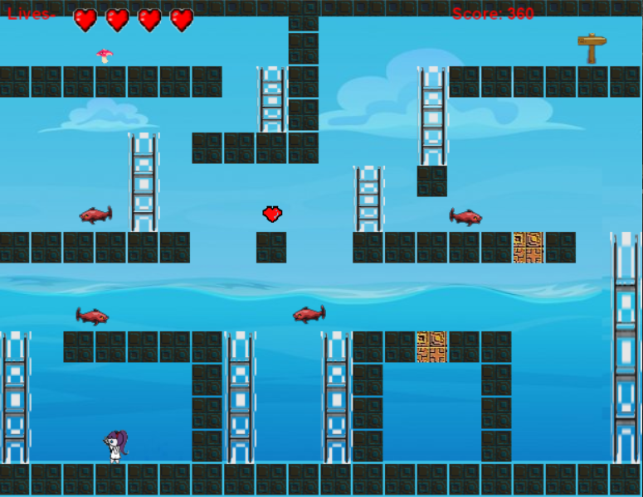

**Genre:**

This game is in the genre of platformers. A platformer game is a game like Super Mario in which the character uses ladders, rope or jumps on to various platforms to complete the game. The scene is usually seen on the side. My game would be a very basic platformer.

**Gameplay:**

For my game you play using the arrow keys. It is a game in which you make use of the ropes and platforms to parkour over certain enemies and squash others to get to the end sign to move onto the next level. Each new level has new enemies you must face, and every level gets harder some even with death blocks. Each new level is set in a different terrain with enemies from that terrain you must face. The end level is the hardest level in which you have the most enemies and death blocks to parkour over to try complete the game. Like most platformers my view is from the side. And quite like Super Mario you have a lot of objects to jump on and a lot of collectibles to collect. Unlike Mario though my game is a lot more basic in this case the girl has to try survive by either killing the monsters or avoiding them completely and with a lot less jumps and a lot more ladders you can complete that.

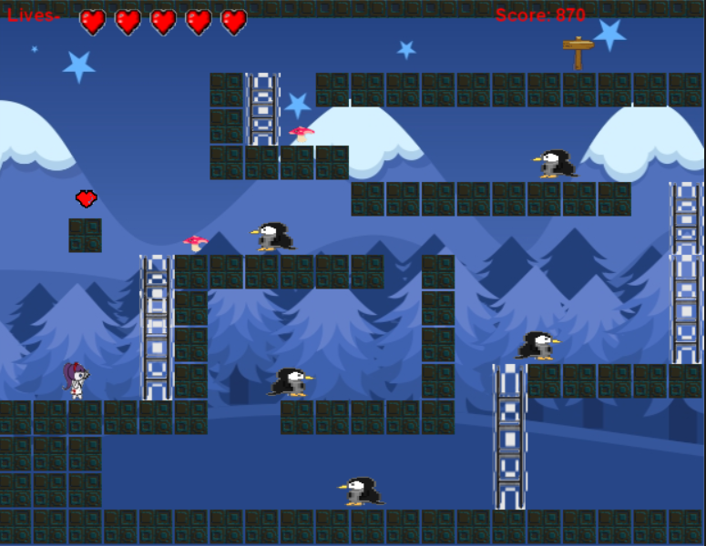 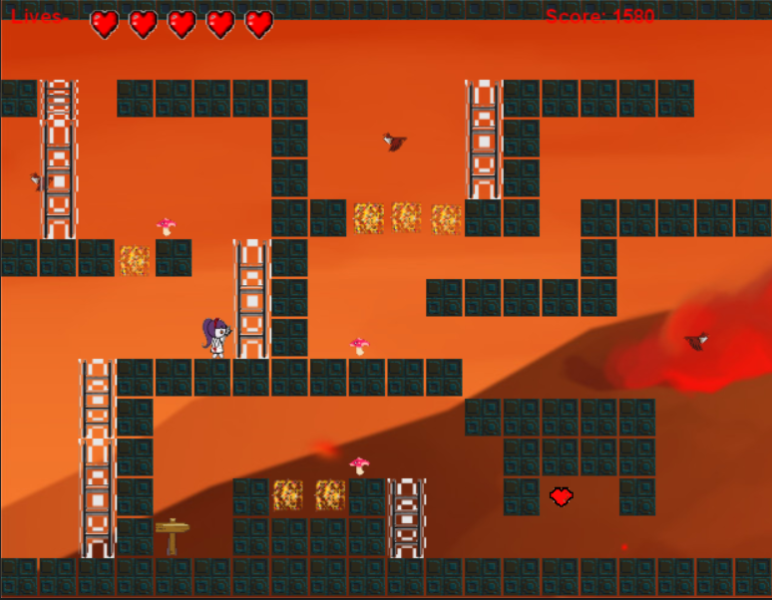

**Features:**

The main features of my game are as such: The main character.

* My main Character is a small girl which you control and try to help escape each level.
* The enemies. Each enemy you meet per level is different. Some are zombies, some are fish some are even cute pink blobs but do not mistake their cuteness for friendliness as they will kill you. Each enemy moves in the exact same way making the game somewhat easier but as I said before some enemies you can kill and some you can’t and that’s up for you to figure out which is which.
* The levels. As I said above each level is different. Some levels are bright and happy and others are dark and gloomy all adding to the atmosphere of the game.

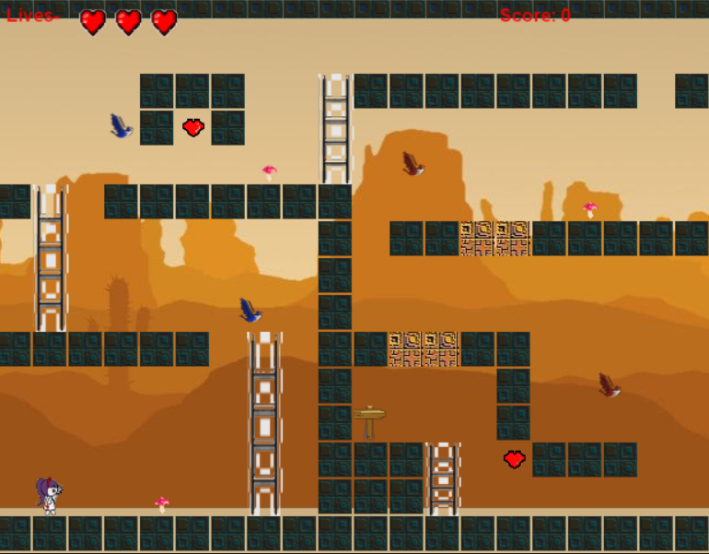 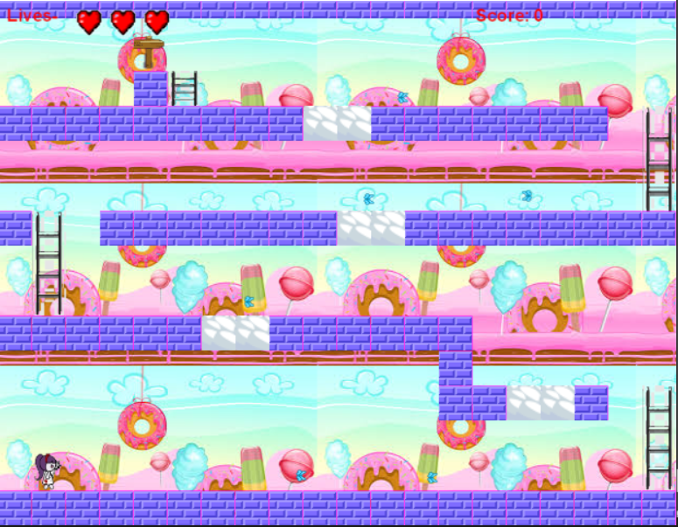

**Setting:**

Each level is made by the various enemies you encounter and the layout of every block which adds to the game. This game is unique in the way that the game itself never gets too hard but in fact develops throughout each level slowly making the game slightly more hard as you progress throughout it.

**Target Market:**

If I were to release this game my target market would be kids aged 6 and up as it is in fact quite an easy game to play. This game would be specialised for fans who have played super Mario as it is in fact quite like it and it is based off the basic idea of the super Mario game.

**Competitive Analysis:**

In this genre there have been many games that have been released like:

* Crash Bandicoot N sane Trilogy
* Super Mario
* Celeste
* Hollow Knight
* Ori and the blind forest (PCGAMES, n.d.)

Each of these games have been very popular and sold worldwide. If my game was to be released it wouldn’t be as popular as these games but I feel my game would do ok.

**Document Summary:**

Personally, I think this would be a great game as its very small and easy perfect for those of a younger age to help get them into games. I also think it would do well as it is an easy and small game to play that generally doesn’t get very hard to play. Lastly I feel this would be a great game because it is quite as entertaining game to play but I feel it would be a game you would only play once as the game does get quite repetitive but overall I feel this would be a worthwhile game to play.

